Product and Seller Display Pages

The product and seller display pages allow the user to view all products and seller respectively, as well as search for specific entities and view individual product and seller pages. The latter article, viewing individual product and seller pages, will be covered in separate documents.

We had a wireframe for the product page and used this or guidance in the design process.

For the moment, this document will focus solely on the product page. Reasons as to why will become clear later as you progress further through this document.

For reference, here is the prior-mentioned wireframe:

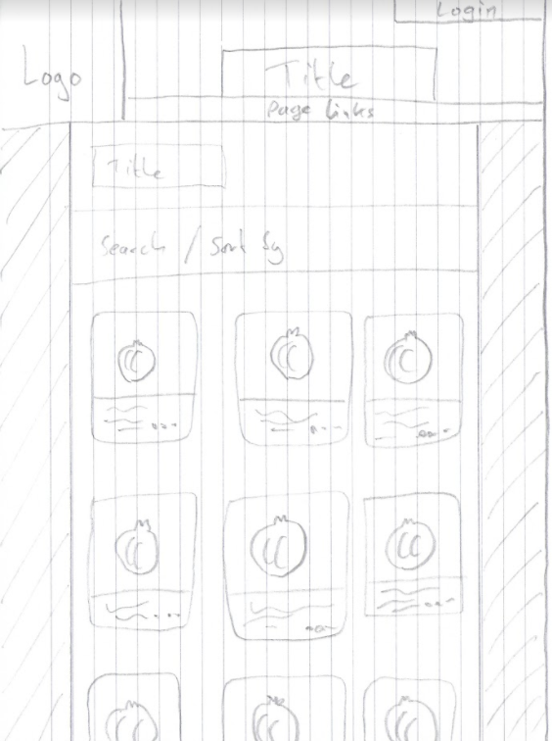

Step one was to construct a query that would call everything we required from the database.

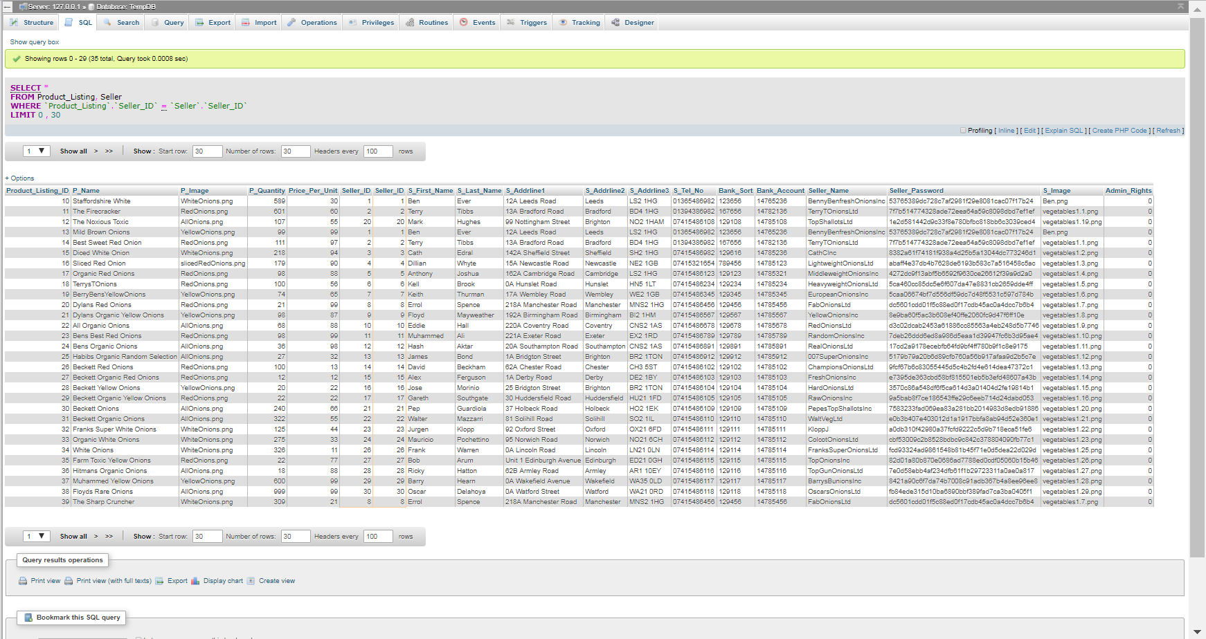

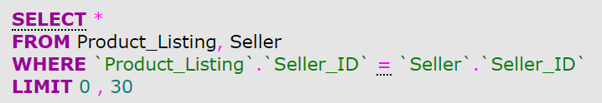

Note: the final build of the website uses Oracle Apex, not phpMyAdmin. The screenshots show phpMyAdmin as that’s where our temporary database was housed prior to the integration of Oracle Apex.

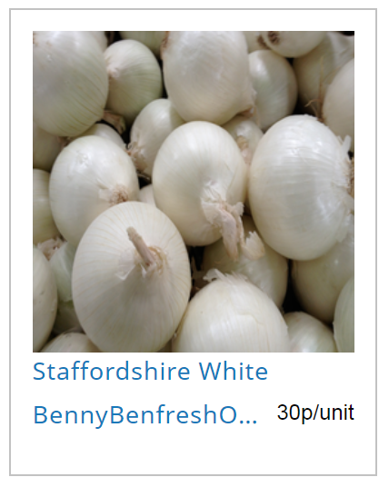Step two was to utilise this query to display all products onto a page on the website.

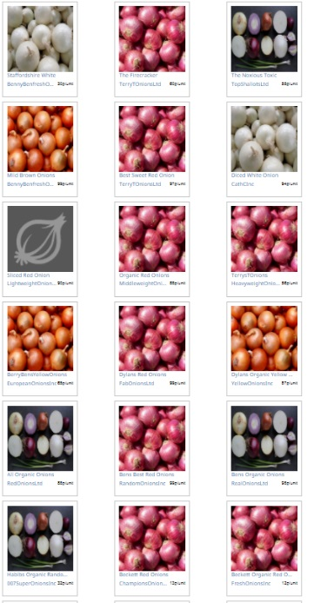

Next, we had to integrate search functionality. This was done by allowing the user to type into a text field, and to select from several options in a ‘sort by’ field. These are stored as variables and are used to alter the query.



For example, users can search ‘onion’, and sort by ‘price low to high’.



This will display all products that contain the word ‘onion’, and list them with the price ascending.

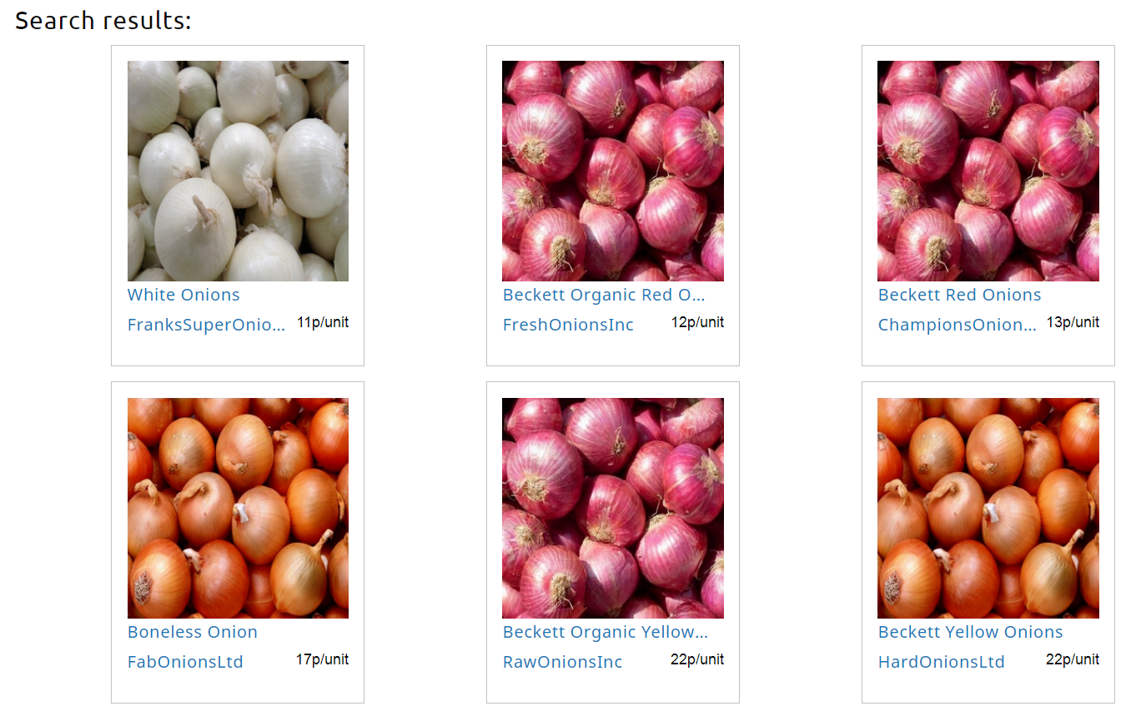

Other ‘sort by’ options are available.

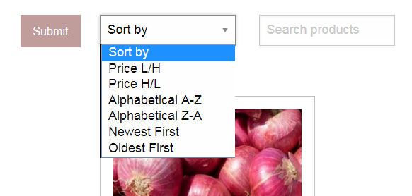

The seller display page works in a similar fashion, with some alterations to the HTML and PHP code, and completely different queries.

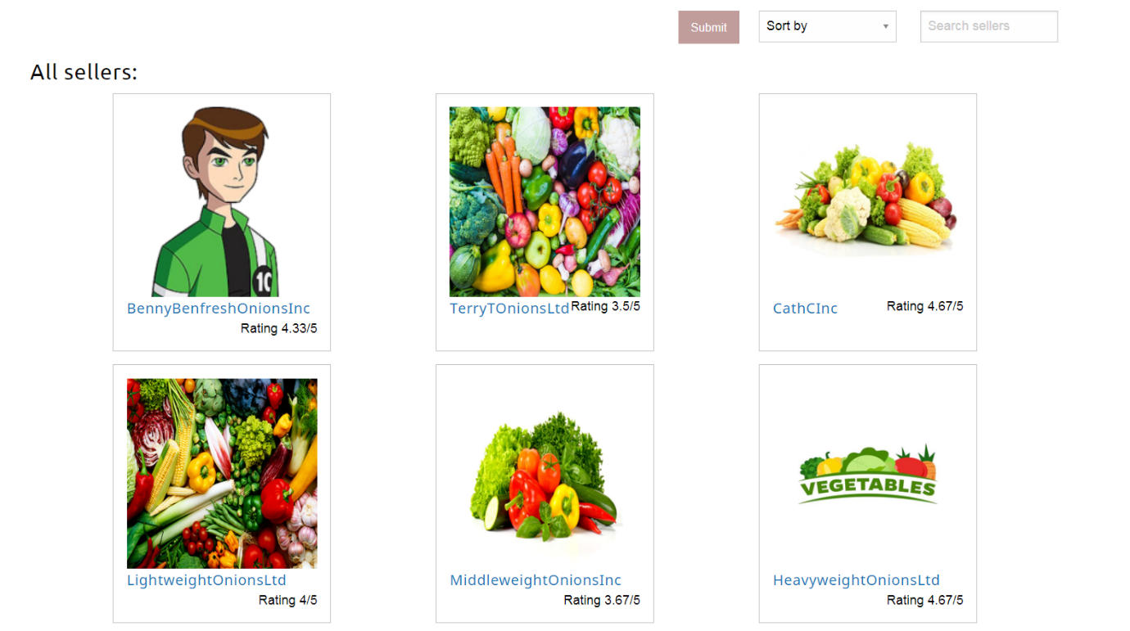

Search functionality also works for sellers.

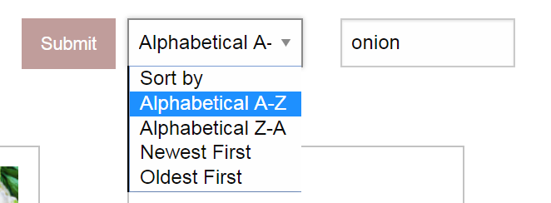

Search for ‘onion’, sorted alphabetically A-Z, produces these results.

